**Motora User Manual**

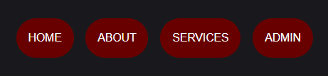

**Make an Account**

**Click on “Admin” in the navigation bar and if you have an account already, put in your login information.**

**If not, fill in the required information to create an account**

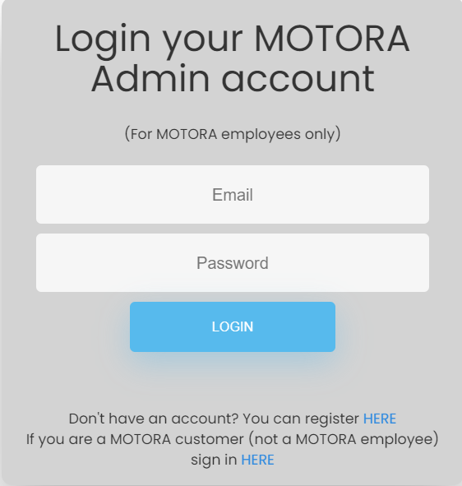

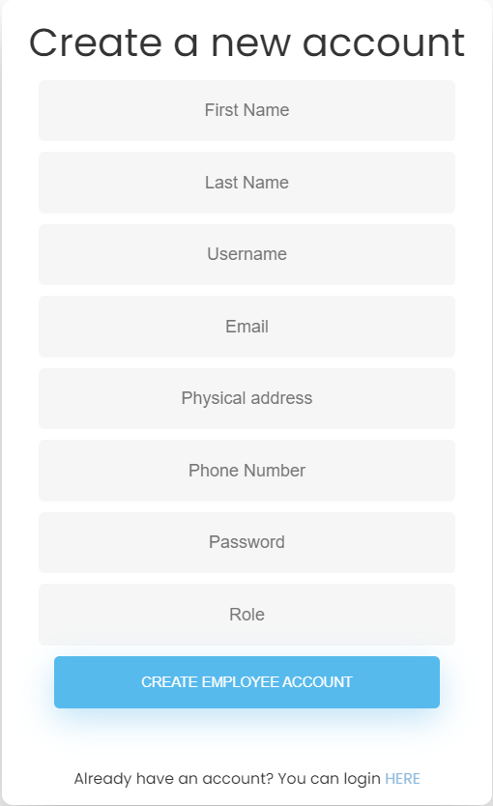

**Admin Dashboard**

**To edit or delete users, click “Manage Users” on the left, and then click either the edit or delete icon beside the user you wish to modify.**

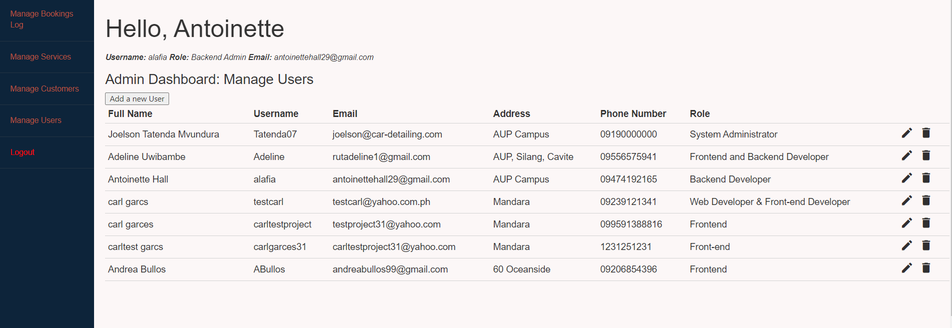

**To view and modify the customers, click “Manage Customers” on the left.**

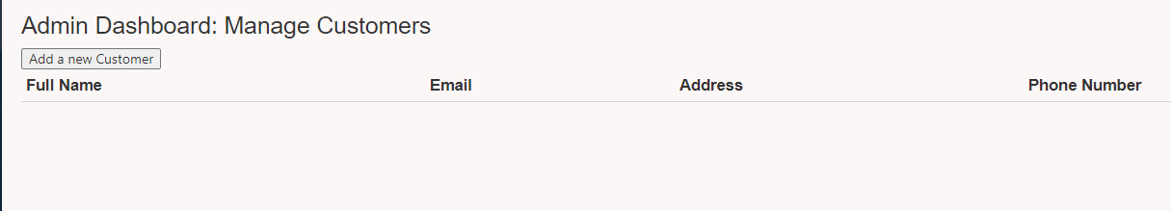

**To edit or delete click “Manage Services” on the left. Click the “Add a new service” button to add a new service.**

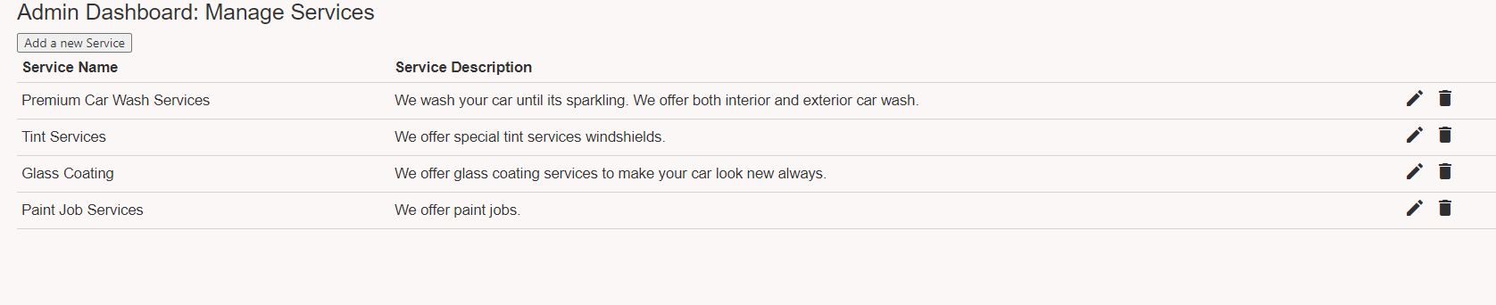

**Click “Manage Bookings” to view all the bookings and edit or delete them.**

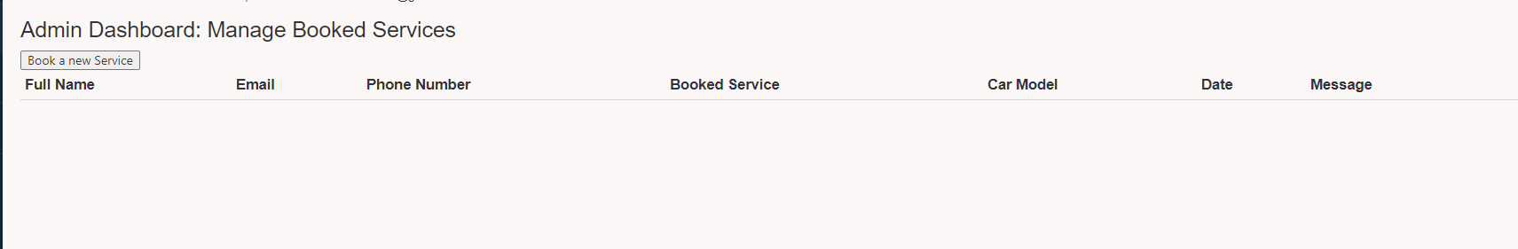

**Services**

**To view which services are available, select “Services” in the nav bar. Click on the service to see a brief description of what each service entails. You can also view the services by clicking them on the home page.**

**Home page**



**Services page**

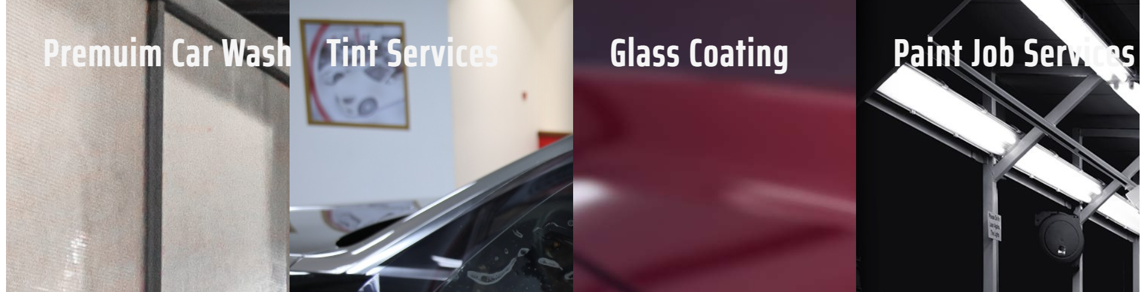

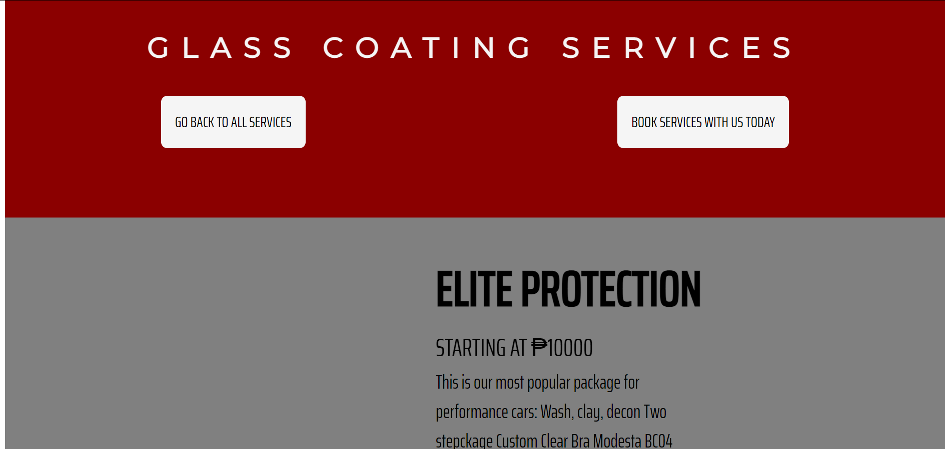

**Click “Book Services with Us Today” to go to the registration form and reserve a service.**



**Fill in the form and click submit.**

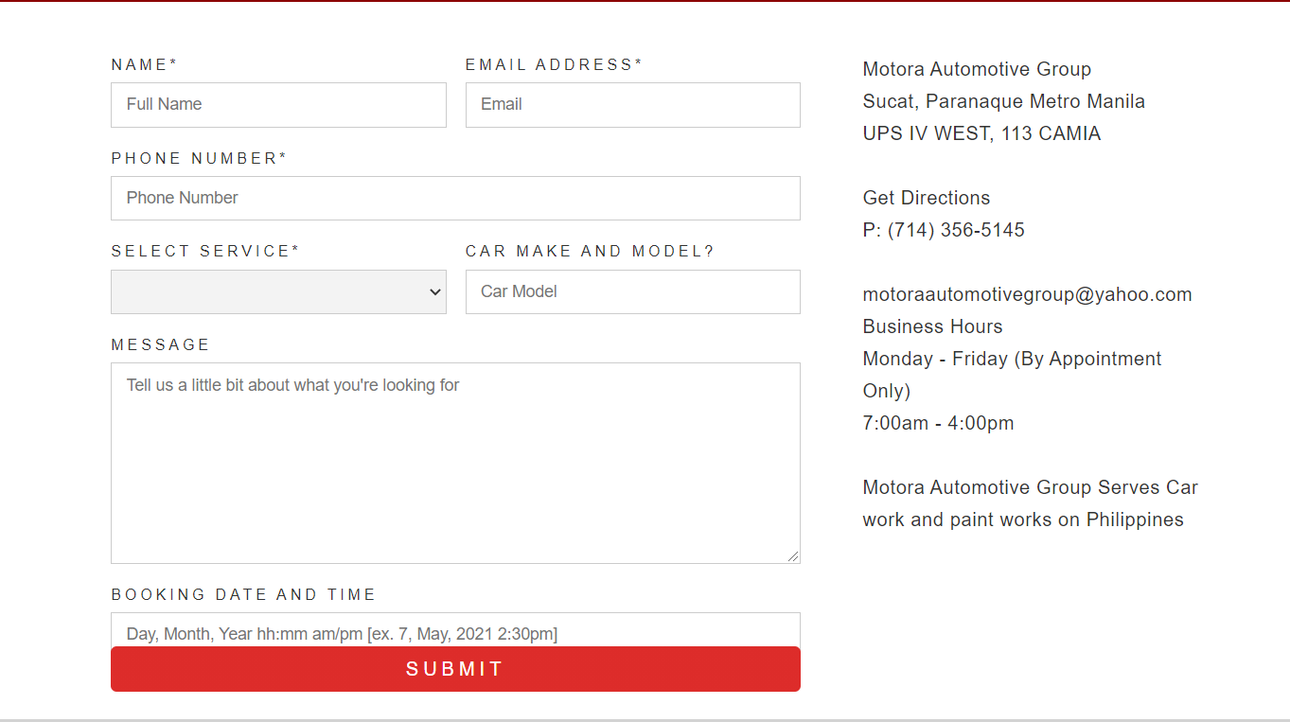

**About Us**

**To learn more about the business, click “About” in the navigation bar. Scroll to the bottom and click “More About Us” to learn more about the developers.**

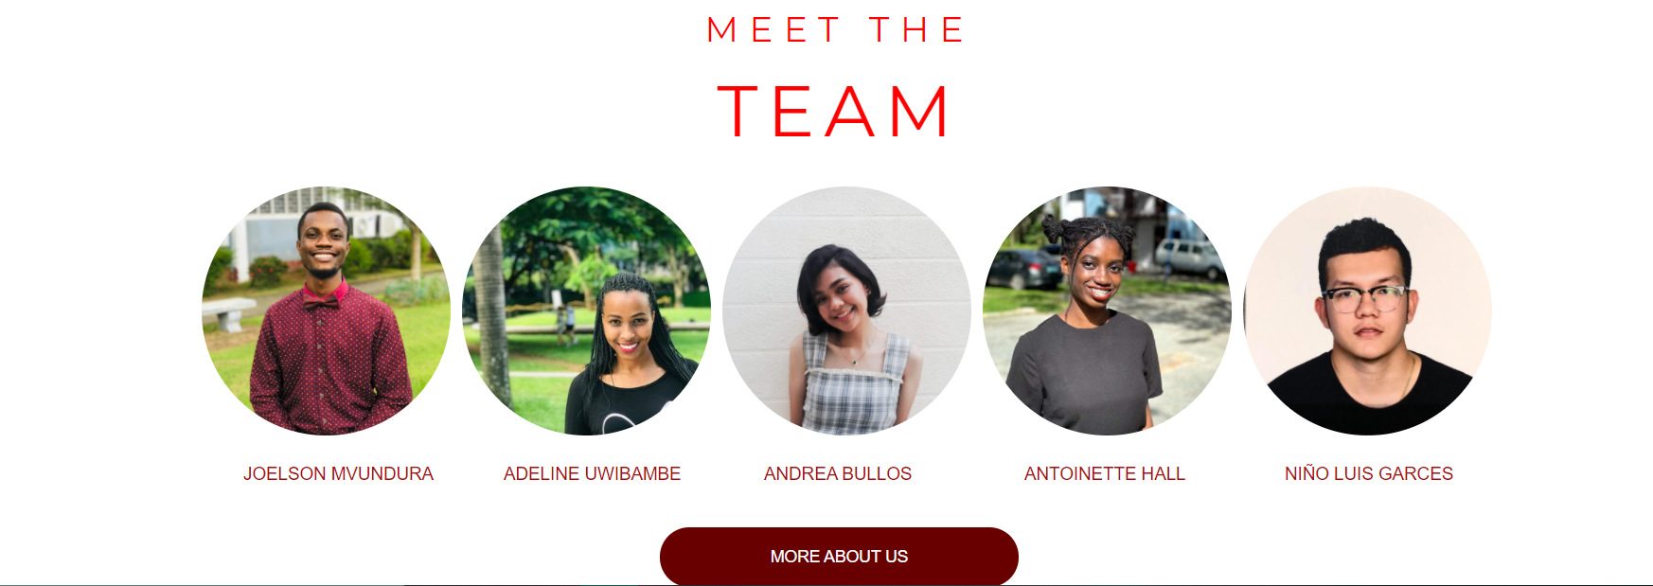

**Hover over the pictures to view a description of each developer and click the Facebook or Twitter logo to go to the developer’s social media pages.**



**Contact Us**

**To sign up to receive our newsletter, enter your email into the input field located at the bottom of each page. Send an email to the email address also at the bottom of each page, or go to the Services Page, click Book a Service, and you can see the phone number and operating hours.**

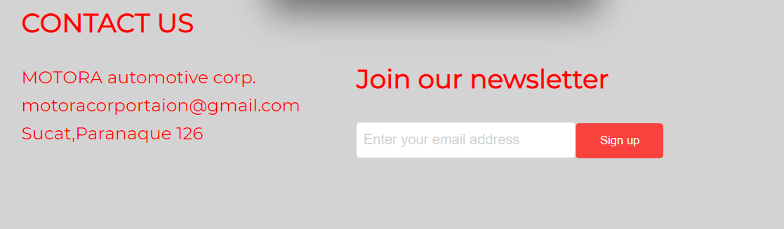

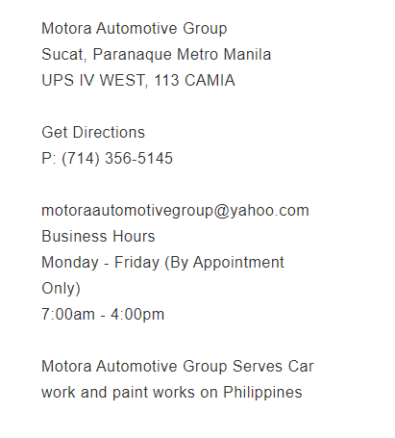

**Entity-Relation Diagram (ERD)**

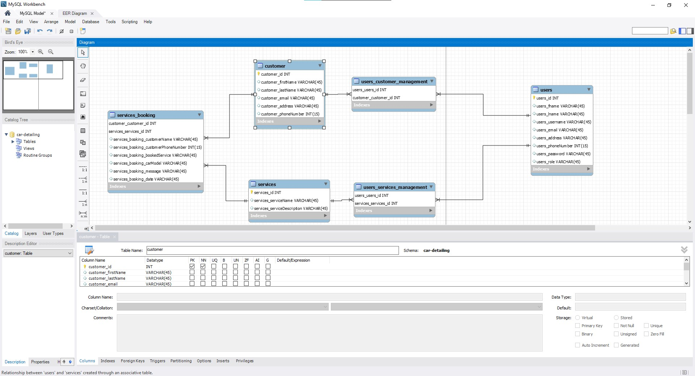

**Unified Model Language (UML)**

